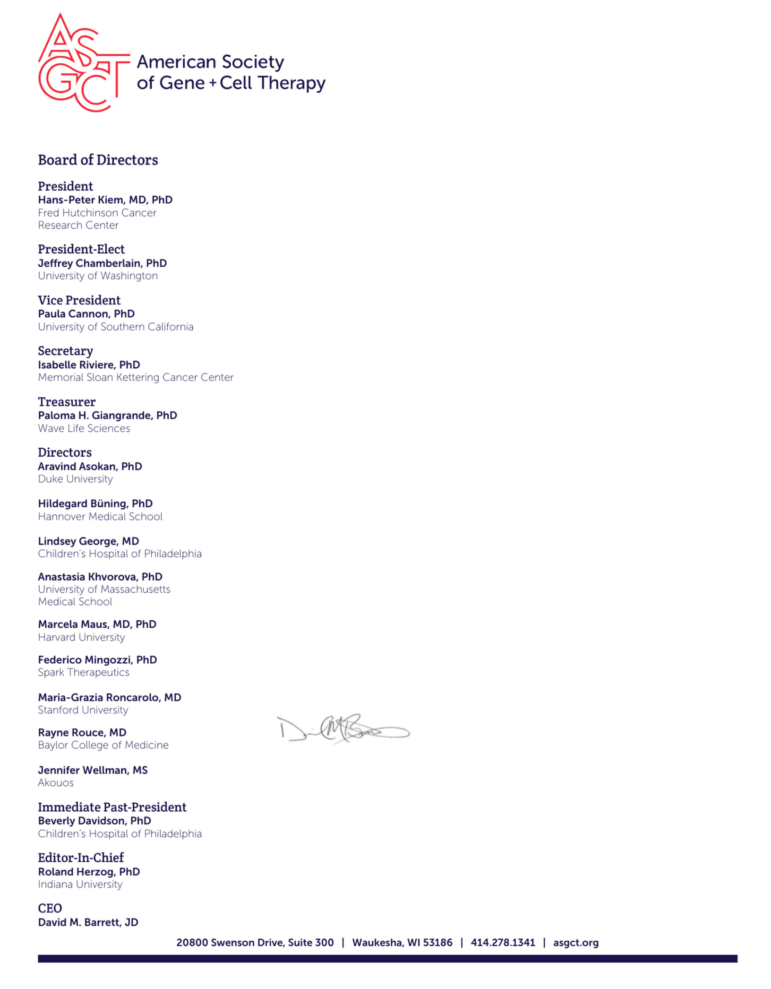

January 24, 2023

(NAME)

(STREET ADDRESS)

(CITY, STATE, ZIP)

(COUNTRY)

Dear (Name):

I’m writing to invite you to the American Society of Gene & Cell Therapy (ASGCT) 26th Annual Meeting, which will be held May 16‐20, 2023, at the Los Angeles Convention Center in Los Angeles, CA, and virtually. The Annual Meeting is the premier event for professionals in the gene and cell therapy field to learn from the latest scientific research, stay up‐to‐date on new technologies, and make career‐ advancing connections with peers.

If you’re planning to attend the meeting in person, you will be responsible for the cost of airfare to and from the meeting, the registration fee, and the cost of the hotel where you’ll stay for the duration of the meeting. During the registration process, you’ll be able to book a room at one of ASGCT’s six host hotels.

If you have any questions, please feel free to direct them to me through the ASGCT Executive Office via phone at (414) 278‐1341 or email at info@asgct.org. I hope to see you at the Annual Meeting this spring!

Sincerely,

David Barrett, JD

Chief Executive Officer

