Program Description: The American Society of Gene and Cell Therapy (ASGCT) is the leading professional membership organization for scientists, physicians, advocates, and other professionals in the field of gene and cell therapy. The goal of the patient education program is to provide accessible, accurate, and responsible information and resources about gene and cell therapy to patients and caregivers. ASGCT collaborates with patient advocacy groups to make sure the resources are clear and useful to the target audience, and the members of the ASGCT Patient Outreach Committee share their expertise in the field to provide scientific accuracy. All resources are available for sharing, so we welcome you to help spread the word!
Link to Patient Education Website: https://patienteducation.asgct.org/
Link to gene editing webpage: https://patienteducation.asgct.org/gene-therapy-101/gene-editing
Credit: Cite American Society of Gene and Cell Therapy on all your pages and link back to the patient education website when possible. Tag @ASGCTherapy on social media.
Contact: Reach out to Ali Kujawski, Patient Outreach Manager, with any questions (akujawski@asgct.org).
How to embed a video on your website or social media post:
- Go to our ASGCT Education playlist on YouTube and view the video you wish to embed on your site. Example: Gene Editing
- Click Share in the bottom right corner of the video.
- Click the Embed Icon.
- Click Copy at the bottom right of the pop-up screen.
- Paste the embed code onto your site wherever you wish the video to be located. Your web designer will be able to implement this.

Social media post examples:
Example post | Suggested image to use
#Geneediting is a type of #genetherapy approach that directly edits pieces of #DNA within the cell. Learn more from @ASGCTherapy’s educational resources. https://bit.ly/3q1f2tc

#CRISPR/Cas9 is a type of #genediting that uses two components: a guide #RNA to find the #DNA that needs to be edited, and a Cas enzyme that cuts and makes the edit. Learn more about other approaches. https://bit.ly/3q1f2tc

#Geneediting can be delivered into cells in vivo, which means its components are delivered directly into the body, or ex vivo, which means the cells are removed from the patient and then edited in a lab before they are returned to the body. https://bit.ly/3q1f2tc
#Geneediting treatments are currently being investigated for individuals with #sicklecell disease, #HIV Type 1, #cysticfibrosis, and more. Use our Clinical Trials Finder to search for open trials: https://bit.ly/3pY0wCn | 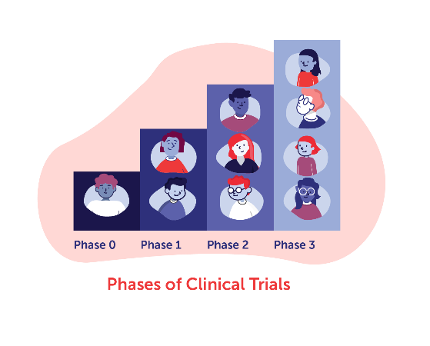
The ASGCT Patient Education program provides accurate, reliable, and accessible information about #genetherapy and #celltherapy treatments. Learn more: https://bit.ly/2USvrT8

Explore the ASGCT Clinical Trials Finder to search open #ClinicalTrials for #genetherapy and #celltherapy treatments. Consider using the diagnosis filter to search by disease. https://bit.ly/3mtzk9q

Web Banners- Right click to save and use these images on your web pages or on social media to increase awareness, be sure to link these images to https://patienteducation.asgct.org/
