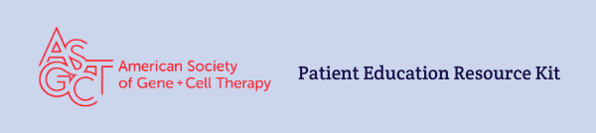
Program Description: The American Society of Gene and Cell Therapy (ASGCT) is the leading professional membership organization for scientists, physicians, advocates, and other professionals in the field of gene and cell therapy. The goal of the patient education program is to provide accessible, accurate, and responsible information and resources about gene and cell therapy to patients and caregivers. ASGCT collaborates with patient advocacy groups to make sure the resources are clear and useful to the target audience, and the members of the ASGCT Patient Outreach Committee share their expertise in the field to provide scientific accuracy. All resources are available for sharing, so we welcome you to help spread the word!
Link to Patient Education Website: https://patienteducation.asgct.org/
Link to Tay-Sachs and Sandhoff Disease webpage: http://patienteducation.asgct.org/disease-treatments/gm2-tay-sachs-sandhoff
Credit: Cite American Society of Gene and Cell Therapy on all your pages and link back to the patient education website when possible. Tag @ASGCTherapy on social media.
Contact: Reach out to Ali Kujawski, Patient Outreach Manager, with any questions (akujawski@asgct.org).
How to embed a video on your website or social media post:
- Go to our ASGCT Education playlist on YouTube and view the video you wish to embed on your site. Example: Tay-Sachs and Sandhoff Disease (GM2)
- Click Share in the bottom right corner of the video.
- Click the Embed Icon.
- Click Copy at the bottom right of the pop-up screen.
- Paste the embed code onto your site wherever you wish the video to be located. Your web designer will be able to implement this.

Social media post examples:
Example post | Suggested image to use
#GeneTherapy aims to be a one-time treatment that may slow or stop the progression of #TaySachs disease and #Sandhoff disease. Learn more from @ASGCTherapy’s educational resources. https://bit.ly/3k8OUsI

#GM2 is a group of rare genetic disorders that progressively damages nerve cells primarily in the brain and spinal cord. Watch this video to learn how #genetherapy may be able to help. https://bit.ly/3k8OUsI

Learn how #genetherapy aims to treat both #TaySachs and #Sandhoff disease by delivering working HEXA and HEXB gene into cells. #ClinicalTrials are now open for this investigational therapy. https://bit.ly/3k8OUsI
The ASGCT Patient Education program provides accurate, reliable, and accessible information about #genetherapy and #celltherapy treatments. Learn more: https://bit.ly/2USvrT8

Most #GeneTherapy is in #ClinicalTrials, a required step in the research process to ensure a treatment is safe and effective. Learn more about clinical trials. https://bit.ly/3rr5rtn | 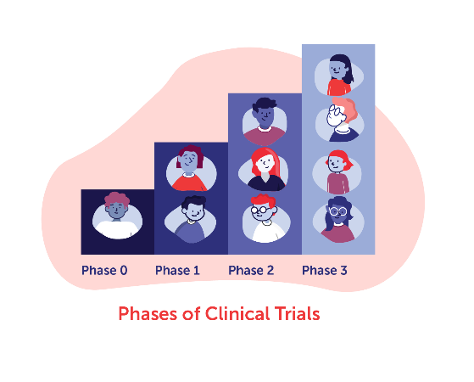
Explore the ASGCT Clinical Trials Finder to search open #ClinicalTrials for #genetherapy and #celltherapy treatments. Consider using the diagnosis filter to search by disease. https://bit.ly/3mtzk9q | 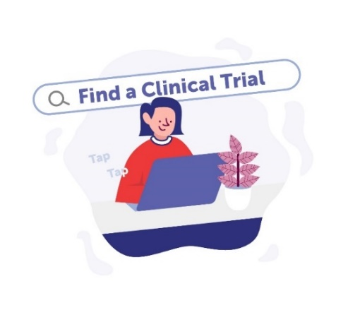

Web Banners- Right click to save and use these images on your web pages or on social media to increase awareness, be sure to link these images to https://patienteducation.asgct.org/
